**changeModule 5: LTE Power Control and MIMO**



**Introduction:-**

The smart phone in LTE network can only be used for the data transmission if its Uplink is synchronized with the network. The LTE uses a technique called as Random Access to do this activity. In this module we will study in details about this technique called as Random Access. We will study both types of Random Access named as Contention Based RA (CBRA) and Contention Free RA (CFRA). We also study about the power control mechanism applied in LTE network and the basics of Open loop, closed loop power control etc.

The third point of discussion in this module will be the discussion of different types of Multiple Inputs Multiple Output techniques are used in LTE. We will study in details about all three aspects of utilizing the power of MIMO to improve the quality of the system like MIMO to increase the coverage in the form of beam-forming, Rx and TX diversity. The MIMO used to improve the capacity of a single user by using spatial multiplexing and MIMO to increase the number of user to use the existing service in MU – MIMO.

**Random Access:-**

The smart phone in LTE network can only be used for the data transmission if its Uplink is synchronized with the network. In other words the UE needs to get registered to the network to do the same a UE has to go through this process which is called as Random Access to get UL synchronized with the network. But before that the UE has to make sure that as if it is connected to the correct PLMN to do this UE will read the Master Information Block (MIB) and the correct cell id (to check whether this cell is not in the barred list) since one UE is able to read so many frequencies which are available to it (may be from other operators) so before that UE needs to get synchronized with the correct frequency. so the terminal will check the Access Class from the cell it has got connected to the network after that only the UL timing synchronization process will start which is called as Random Access Procedure.

The Random Access is a procedure by which the UE terminal will inform the network about its willingness to get connected to the network and start transmitting the UL data. Unlike in UMTS (where RACH carries some short message transmission also), RACH in LTE is used only for the initial access and does not carry any other data. Other than from the initial access the Random Access procedure is used to wake up the UE from the sleep mode as well. Broadly the Random Access Procedure is used in the following three cases:

1. **Initial Access:** When the UE is connected to the network like on switching on it means a transition between the RRC idle to RRC connected mode. And when the UE is recovering from Radio Link failure where it is coming out from a out of coverage to coverage area.
2. **In RRC connected:** like in case of any DL data coming but the UL is not synchronized or in case of UL data or HARQ Ack/NACK transmission which you are connected and want to send a message or when Timing Advance is required for the correct positioning of the UE in the network.
3. **Handover:** or in case of handing over to the target cell from the source cell the UE needs to do the Random Access procedure with the target cell to the synchronization from the network.

So in simple words whenever the UE needs to get synchronized to the network for the UL transmission Random Access procedure is always required. So initially the UE does not have any resources already available with itself so the UE will send the RA request on a shared resources called and RACH preamble since there will be other UE in the cell which will be competing with this UE so there will be possible chances of collisions, RACH reattempts and RACH failure which will be discussed in this section of our studies.

**Random Access procedure** in LTE is has two form defined in EPS: 1. Contention Based Random Access (CBRA): where the inherent risk of collision is there between different UE in those cases where the state of UE is not known to the network this kind of Random Access is compulsory whereas in other cases it may or may not be required and 2. Contention Free Random Access (CFRA): where is state of UE is already known to the network like in case of handover or DL data coming to the UE we may have Contention Free Random Access (CFRA). A point to be noted here is CFRA is a licensed feature which may not be enabled in any network so in those cases what we will get is only CBRA. Both type of Random Access procedures are outlined and explained below.

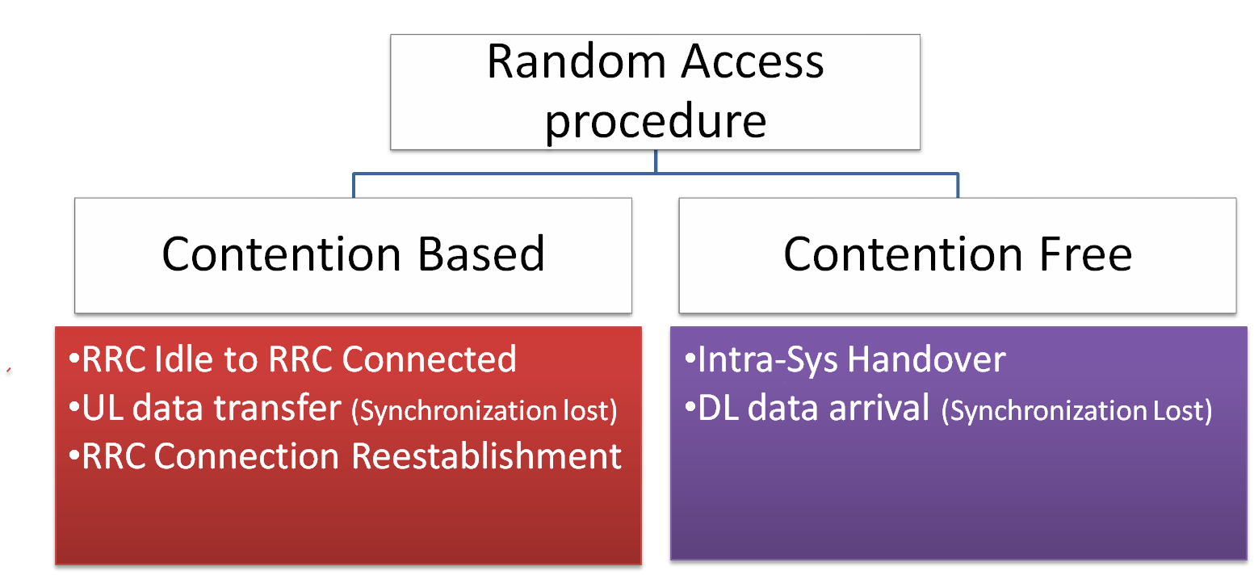

**Contention Based Random Access (CBRA) Procedure:-**

The CBRA is explained and outlined in a four step procedure as shown and explained below:

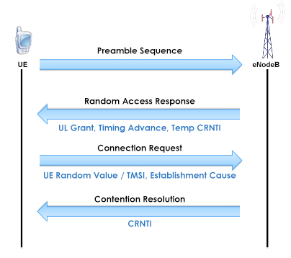

**Step1:**

In the first step the terminal has to select one of the 64 available preamble sequence (which is a 5 bit ID having one bit reserved for the type of preamble) to initiate the random access. In case CFRA is enabled in the system and there are x number of preambles reserved for CFRA then the UE will select preamble from 64-x preambles. The UE also have to give its identity to the network so network can address the correct UE in further steps for this purpose the UE sends one RA-RNTI (Random Access Radio Network Temporary Id) which is determined by the timeslot on which the preamble was given to the network.

The initial power settings of this RACH preamble will be based on the open loop power settings which it will get from the RSRP (Reference Signal Received Power) and SINR considering path-loss into consideration. In case of no response from the network the UE will increase its power and resend the preamble again.

**Step 2:**

In this step the eNB will address the UE with RA-RNTI calculated by the TS of RA preamble and provide a RAR (Random Access Response) to the UE on the physical downlink shared channel PDSCH. In the event of collision between two or more UEs it means they all have same RA-RNTI they will all be addressed with a RAR. The RAR will contain: a temporary Cell ID named as **C-RNTI** for the further communication, one **Timing advance** value for the compensation of round trip delay required for the distance how far the UE is located from the eNB and one **UL grant** for initial access on ULSCH channel for transmission in the next step 3. The RAR message may also contain a **back-off** indicator in case the eNB wants to instruct any UE for collision if it is already detected. The UE which has got the back-off indicator will not retry for the random access again for a given period of time as instructed by the eNB.

**Step 3:**

In the next step after the UE receive the RAR, it will send and an RRC connection request to the eNB along with that it will a UE ID in the form of TMSI or any random number. TMSI if the UE is already known to the network as explained in RACH introduction or any unique Random value of 48 bits if the UE state is not known to the network like in case of initial access. The UE in this step is identified by the C-RNTI it was given in step 2. This message will be the token of first scheduled transmission done by the network for the UE and now the UE will send this message on PUSCH channel using HARQ mechanism for the retransmissions if required. This message will also contains an establishment cause i.e. the reason why UE wants to connect to the network e.g. for RRC connection establishment, TAU or for any scheduling request. **In case of collision scenarios like two or more UE sends same preamble on same RA-RNTI got the same C-RNTI in step 2 then now in step 3 there will be following cases 1. When all UE will have interference, none of the UE will be decoded or 2. One of the UE will be decoded and the others remain unresolved. The next step 4 will help us understand and provide a quick resolution of this contention scenario.**

**Step4:**

As soon as the message from step no 3 is transmitted two timers will automatically start activated.

**T300:** Define the amount of time for the UE to wait for the response of RRC connection message it is sent in step 3. The RRC establishment procedure will fail will this timer value is expired.

**Contention Resolution Timer:** similar to T300 if this is expired RA procedure will start from step 1 again but in case there is HARQ non acknowledgement (HARQ/ NACK) for message in step 3 then it will start from step number 3 again and this timer is reset.

We have understood the two different cases of collision scenario in step 3 end where in one of the case one of the UE under the collision will be decoded and in the other case none of them will be decoded. So in step 4 whichever UE is decoded it will go receive message from step 4 which will contain the permanent C-RNTI and it will be for the UE which is decoded from step 3 and this permanent ID will remain with this UE till its RRC connection is alive. The UE in this step is addressed using the TMSI or Random value which was given in step 3. The UE who receive this message will go further rest all of them will restart the RA procedure again after T300 is expired.

**Contention Free Random Access (CFRA) Procedure:-**

This type of random access procedure is always initiated by the network (eNB) for example when the UE is getting an handover from the source cell to the target cell so in this type of random access scenario the eNB will assign any RACH preamble from its reserved pool of RACH preamble if CFRA is enabled in the system. Since the full process in this RACH procedure is controlled by the eNB so there is no chance of collision hence it is pretty simplified RACH procedure the common steps any ways are shown below.

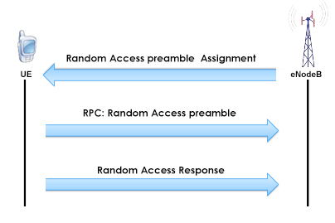

**Power Control:-**

We need to understand the power control mechanism of LTE network but before that let us understand what exactly is a power control in telecommunication and how is it beneficial to a telecommunication network:

Power control can broadly been explained as an intelligent method of selecting the transmit power of any given node in the network to achieve good performance in the network but what does it means since we know more transmit power means more signal power so by keeping more power we need to get better results. Is it correct no..

To explain this I will show you the Shannon’s theorem which link the available bandwidth to the capacity utilization of that bandwidth.

The important point to understand from this equation is you can achieve any given capacity from as low as possible bandwidth if in case you have a proper S/N ratio and S/N is directly proportional to capacity of the system. Where S/N is the signal to noise ratio which means how much better the desired frequency signal is from all other sources of interference. If in case we are transmitting on a higher power than required our signal can became th interference for the other signals. Therefore the power control mechanism is required in any telecommunication system so that every single node should transmit on the optimum power which is required and the other implications of Transmit power is its impact on the human body therefore EMF control is also a concern.

Other than interference the higher transmit power will also have one more concern which is the higher battery consumption which is a serious concern for the handheld UEs. So therefore a good power control mechanism is the one which keeps the nodes on the lower power maintaining a proper SINR values. Power control in Radio communication is very important compared with the wired communication because the amount of losses which you will face is radio communication is much more than in wired communication. And Power control in UMTS is very elaborate as all the UE are sharing the same available bandwidth and there is intra-cell interference also to be considered whereas in LTE there is only inter-cell interference which needs to be handled.

Following are the few terms which you need to understand in any power control system.

**Closed Loop Power Control:** This type of power control is based on the feedback provided by the system for example you are talking to some and he/she can provide you an instant feedback to increase of decrease your voice according to if he/she can be able to hear you properly or not.

**Open Loop Power Control:** This type of power control is based on non feedback system or when providing feedback is not possible for example the UE is accessing the network for the first time there will not be any feedback system to control the power so the UE will use some initial power which it has received from the reference signals at the time of latching and it will use this power as the initial power to access the system.

The power control mechanism in LTE is applied for the UL only. In DL it is power allocation rather than power control mechanism is used where dynamic power are assigned to the control channels (like PDCCH and PHICH) from the feedback received from the UE in the form of Channel Quality Indicator (CQI).

In the uplink the power control in LTE uses combination of open loop power control and closed loop power control. Unlink UMTS in LTE transmit power control command (TPC) is not required to send on a regular basis rather it happens on the event basis because Intra cell interference is not a problem in LTE.

The UL power control of LTE on different physical channels can be shown by the following formulas:

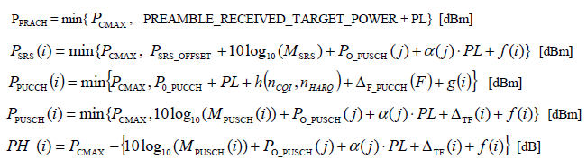

The formulas above are taken from **ETSI 3GPP TS 36.213**. The detailed description of all of these formulas are out of the scope of this course but for our understanding basic formula design of each of the formulas. Other than Power headroom PH formula all the other formulas can be shown like.

***Pchannel = {Pcmax, formula, f(i) or g(i)}***

There is a ***Pcmax*** and one formula so any value between these two whichever will be less will became the transmit power of that channel also there is one value which is f(i) which describes the closed loop feedback part of it based on the feedback provided by the eNB.

**PUSCH power control:**

The power control in physical uplink shared channel can be explained using the formula:



Where

 is the number or PRBs assigned for the PUSCH, valid for sub-frame i and is directly proportional to the i to maintain same power spectral density.

PL is the path-loss calculated by the UE with a correction factor  to consider feeder and other deployment losses.

 is a compensation factor for modulation coding and transport format.

 is a calculated value of *P*O_NOMINAL_PUSCH*( j)* which is a cell specific value can be changed in the network by upper layer and *P*O_UE_PUSCH*( j)* is a RRC configurable value and j could be equal to 0 or 1. The formula is shown below.

*P*O_PUSCH*( j)* = *P*O_NOMINAL_PUSCH*( j)* + *P*O_UE_PUSCH*( j)*

**PUCCH Power Control:**

The power control in physical uplink control channel can be explained using the formula:



Which is also similar the above one.

One more important formula to look for in UL power control is called as **power headroom** or PH formula which represents how much more power is left with the UE to transmit in addition to its power transmission for current transmitting channels by looking at formula number 5 from the above formula given in the beginning of power control for PH(i) the formula looks something like this:

Power Headroom (PH) = Pcmax – Ppusch which means it’s the max power of UE minus the power of transmission for PUSCH channel. If the PH represents a positive value means the UE can transmit more power or more data if in case the network permits otherwise not.

**Concept of Multiple Inputs Multiple Outputs (MIMO):-**

The benefits provided by the multiple antenna in any communication system was known from a very long time in terms of the transmit diversity where the **same data is transmitted from two or more different antenna located at certain distance to provide better performance.** The **purpose** of including MIMO techniques in LTE was to **give an improved performance** to the cell edge users and wherever the radio conditions are good it may provide enhanced user data rate and may be more number of users. In this section we will study all benefiting aspects and all varieties of transmission modes provided by the multiple antenna techniques in a LTE network.

To have a better understating on MIMO techniques used in LTE network let us understand some basic terminology used in LTE and what exactly does it means:

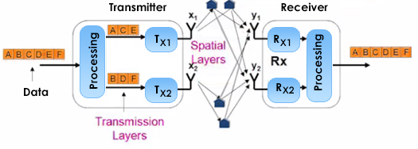

**Spatial Multiplexing:** Since we know the transmit diversity scheme where different transmission layer transmits the same data streams. now in spatial multiplexing the **different transmission mode send different data streams which will help the network to improve the throughput of the system**.

**Transmission Layer:** This layer represents the number of antennas streams which can be used to provide the different data streams or the same data streams. If it is providing the same data stream MIMO can be used to provide enhanced coverage but no impact on the throughput. If the transmission layer can provide different data streams as shown in the figure above the MIMO technique can be used to provide more throughput.

**Rank:** The rank will inform us how many different information streams are sent. In LTE rank 1 means the same information is sent from all four antennas and rank 4 means different information is sent in all four antennas.

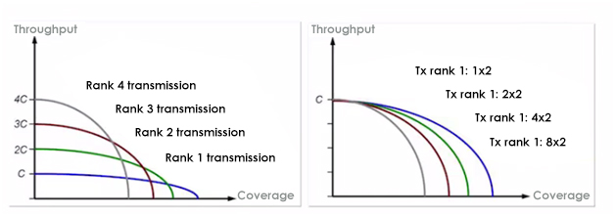

The figure above can show the impact on coverage and throughput of different number antennas and different rank in used. The left figure shows four antennas are used and the impact on coverage for all four rank where the rank 1 with four antenna have more coverage because of transmit diversity but less throughput and a rank 4 antenna have more throughput but since it required a better SINR value therefore it is have the least coverage.

The figure on the right represents a rank 1 scheme with different antenna and by increase the number of antenna or number of transmission layer the coverage is getting improved but there no impact on the throughput value since all transmission layer are transmitting the same data streams.

**PMI Pre-coding Matrix Indicator:** This is a feedback provided by the UE to indicate which kind of coding from a predefined code book the eNB should use which is known to both UE and eNB. It is just like an index of the book. The UE is able to identify instantaneous channel conditions and decide and after that provide this feedback to the eNB if the UE is able to decode the data coming from two antenna separately means the UE can be served with Rank 2 data streams otherwise both transmission layer will be sending the same data streams like in transmit diversity. The antenna technique which uses the PMI feedback system can serve the slow moving users.

Together the Rank Indicator (RI) and precoding matrix indicator (PMI) are the feedback of a UE to the eNB based on which the eNB makes a decision to choose the coding which is required to be done based on the pre defined code book lookup.

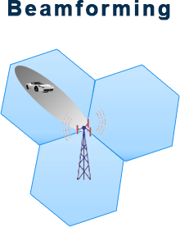

**Beamforming:** The beaforming can be produced to improve the coverage experienced by a single UE or a group of UE where the coverage pattern changes by focusing the energy of eNB in a given direction. By the feedback provided by the UE of the channel conditions it is experiencing. And it can improve but UL or DL coverage.

**Transmission Modes:**

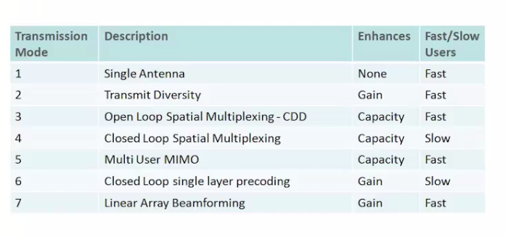

Shown above are different **transmission mode or antenna configuration** defined in 3GPP LTE release 8. The different transmission mode **differ from each other in terms of conditions required and the benefits they provides** now we will discuss each of these 7 transmission modes in details.

**Transmission Mode 1:** This is actually not a multiple antenna technique used in LTE. The TM1 is a **single** layer mode which can have Single Input Single Output (SISO) or Single Input Multiple Output (SIMO) configuration where the UE will perform a maximum ratio combining to improve the SNR values.

**Transmission Mode 2:** This mode is operational for the **transmit diversity** that means the same data streams will be transmitted from more than one antenna this mode will not increase the data rate but will provide coverage gain to the link and since feedback is not required so this transmission mode can be used for the high speed user equipment. Low co-relation between the different antennas are required for this mode of operation which can be provide by maintaining some inter antenna distance.

**TransmissionMode3:** This transmission mode provide low **spatial multiplexing** of rank up to 2 only with no feedback to provide support to high speed UE’s. this transmission mode provide a better throughput which can be provided by a cyclic delay diversity (CDD) which actually is a predefined codebook in spite of a PMI feedback where a pre-coding matrix is cycled across the frequency band to provide spatial multiplexing.

**Transmission Mode 4:** This transmission mode is provided along with a **closed loop with spatial multiplexing** up to rank 4 and a tight PMI feedback is required to provide the instantaneous channel conditions to the eNB. Since the tight feedback is required in this mode so this mode is not feasible for the high speed UE’s but it provide a better throughput as more ranking can be served with this mode.

**Transmission Mode 5:** This is a **multi user MIMO** technique which is similar to mode 4 with the only difference that each spatial layer can serve a single user and no PMI is required so it can be used to serve the fast moving UE’s.

**Transmission Mode 6:** This mode is called as a **single layer closed loop multiplexing mode**. This mode of antenna configuration is similar to Mode 4 which is the transmit diversity with rank 1. The difference is in spite of transmit diversity this mode uses the spatial multiplexing to create a Beamforming effect which provide a 1 or 2 dB gain over TM2. Since PMI feedback is required so it is not suitable for fast moving UE’s.

**Transmission Mode 7:** This also a rank 1 mode. Which is based on **beamforming** technique using linear antenna array. Which combines UE specific reference symbol multiplexed with the data that means this mode is suitable for the cell edge user as it helps canceling the interference caused.

**References:**

3GTS 36.300 (10.1.5)

3GTS 36.213 (6)

3GTS 136 101 V11.2.0 (2012-11)

3GTS 36.211

LTE – THE UMTS LONG TERM EVOLUTION Theory to Practical

http://en.wikipedia.org/wiki/Power_control

<http://www.sharetechnote.com/html/RACH_LTE.html>

<http://4g-lte-world.blogspot.in/2013/04/random-access-procedure-rach-in-lte.html>

<http://www.sharetechnote.com/html/PowerControl_LTE.html#Power_Control_in_LTE>

http://www.slideshare.net/zahidtg/lte-transmission-modes-and-beamforming